## **University of Missouri**

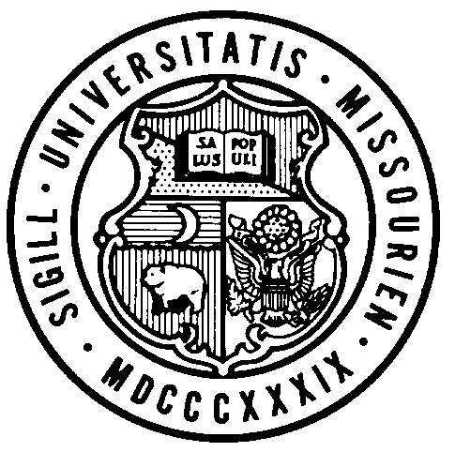

**Board of Curators**

**Special Meeting**

**Friday, October 30, 2020**

**8:30 A.M.**

Originating:

From remote locations via Zoom and/or conference telephone.

**Please click the link below to join the webinar:**

<https://umsystem.zoom.us/j/99197394966>

**Or Telephone:**

**Dial US: 1 301 715 8592**

**Webinar ID: 991 9739 4966**

**AGENDA**

**PUBLIC SESSION – 8:30 A.M.**

Call to Order – Chair Brncic

Roll Call of the Board of Curators

**General Business**

Action

1. Resolution for Executive Session of the October 30, 2020 Board of Curators Special Meeting

**8:35 A.M. BOARD OF CURATORS MEETING-EXECUTIVE SESSION** (time is approximate)

#### The Board of Curators will hold an executive session of the October 30, 2020 special meeting, pursuant to Sections 610.021(1), 610.021(3), 610.021(12) and 610.021(13) RSMo, for consideration of certain confidential or privileged communications with University Counsel, personnel and contract items, all as authorized by law and upon approval by resolution of the Board of Curators.